**Project Report**

**Analyzing Housing Prices in Metropolitan Areas of India**

* 1. **Introduction**
  2. **Overview**

The objective of analyzing housing prices in metropolitan areas of India is to gain insights into the trends, factors, and patterns that influence the real estate market in these urban centers. By conducting this analysis, we aim to understand the dynamics of housing prices and identify potential drivers for price fluctuations

* 1. **Purpose**

Houses with best facilities in India. By analysing the  number of bed rooms and Services provided , may somebody with the dilemma to buy or not buy his/her own houses based on price and best facilities

1.3. **Problem Statement & Design Thinking** Can make this visualization application available for people, for more insights and ideas can ask for payment and also can give these insights  to make the understand and help in the sense of buying house.

* 1. Empathy map



* 1. Ideation and the brainstorming

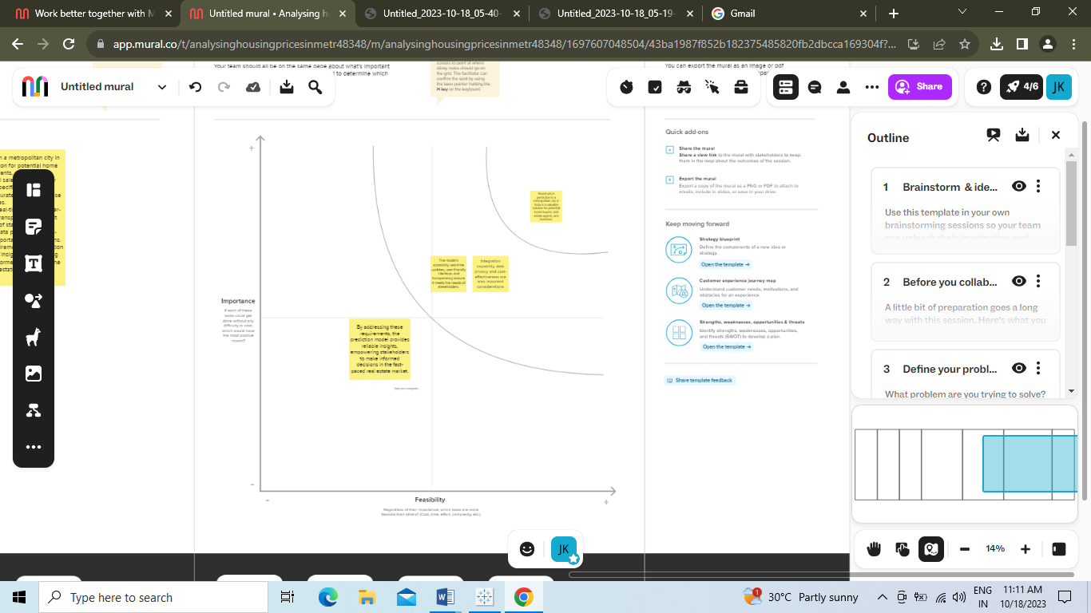

* 1. Result

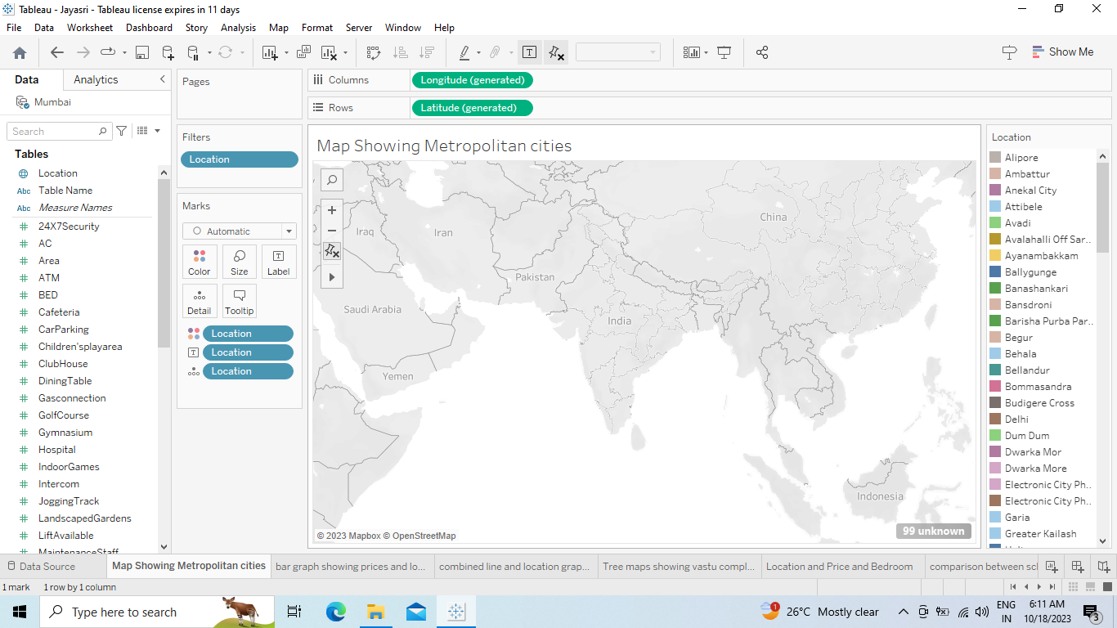

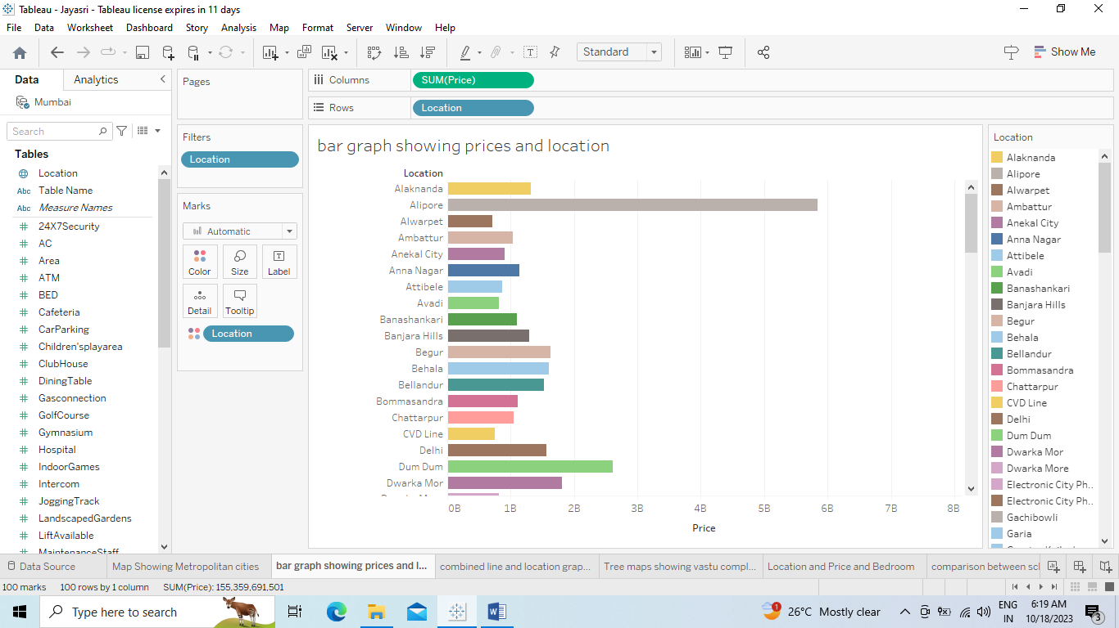

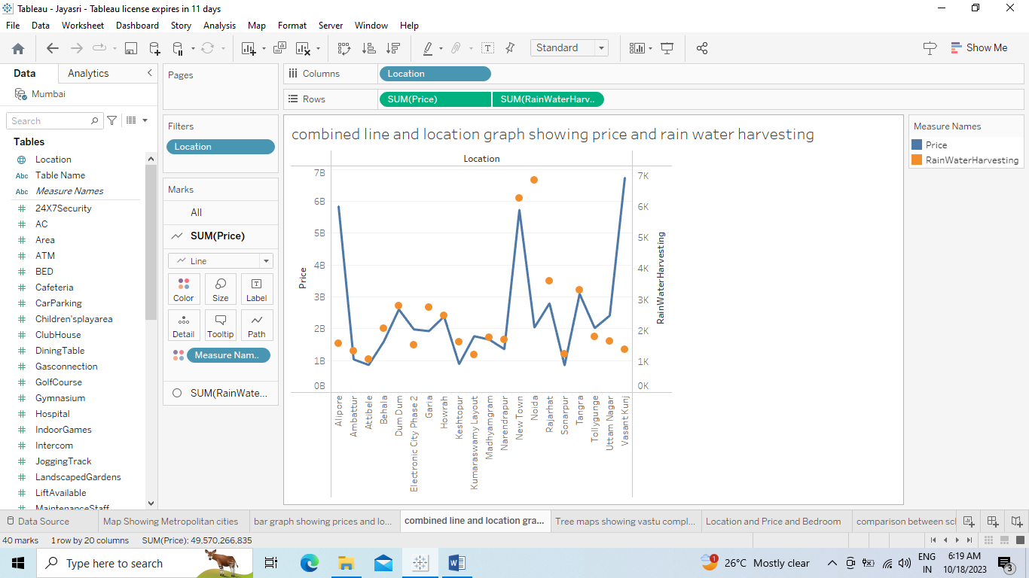

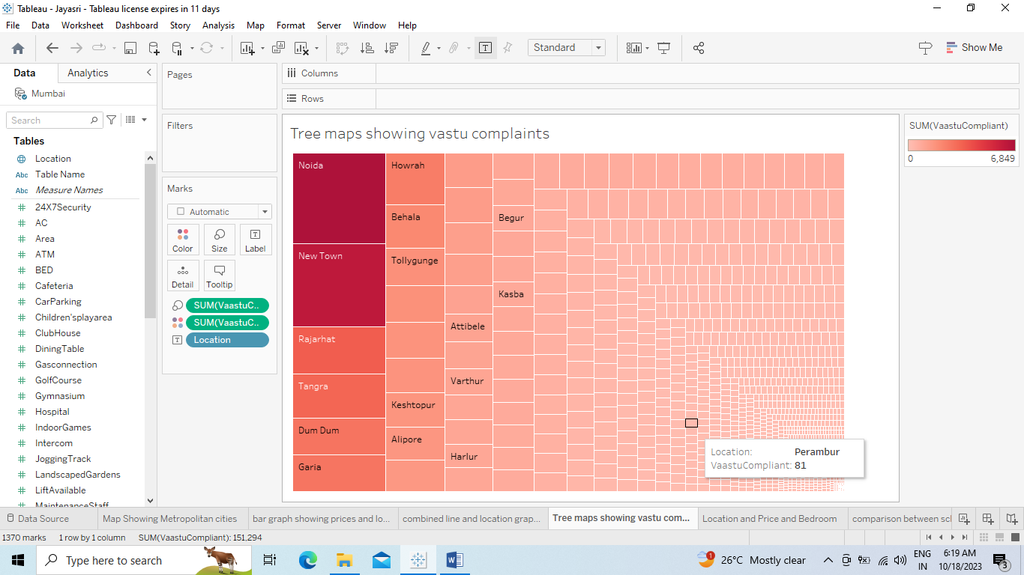

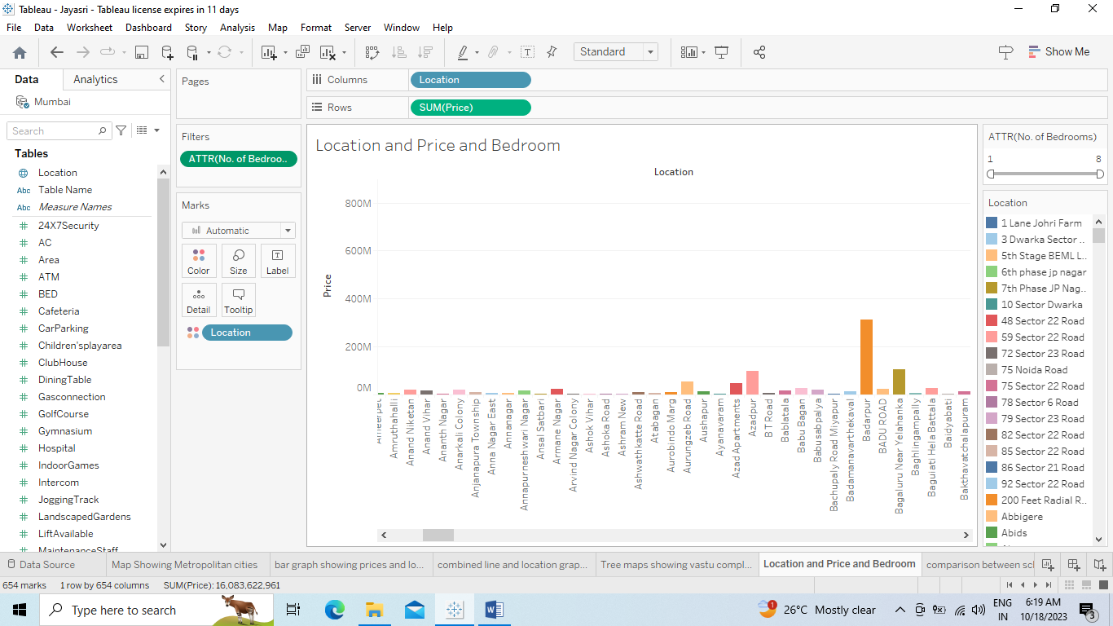

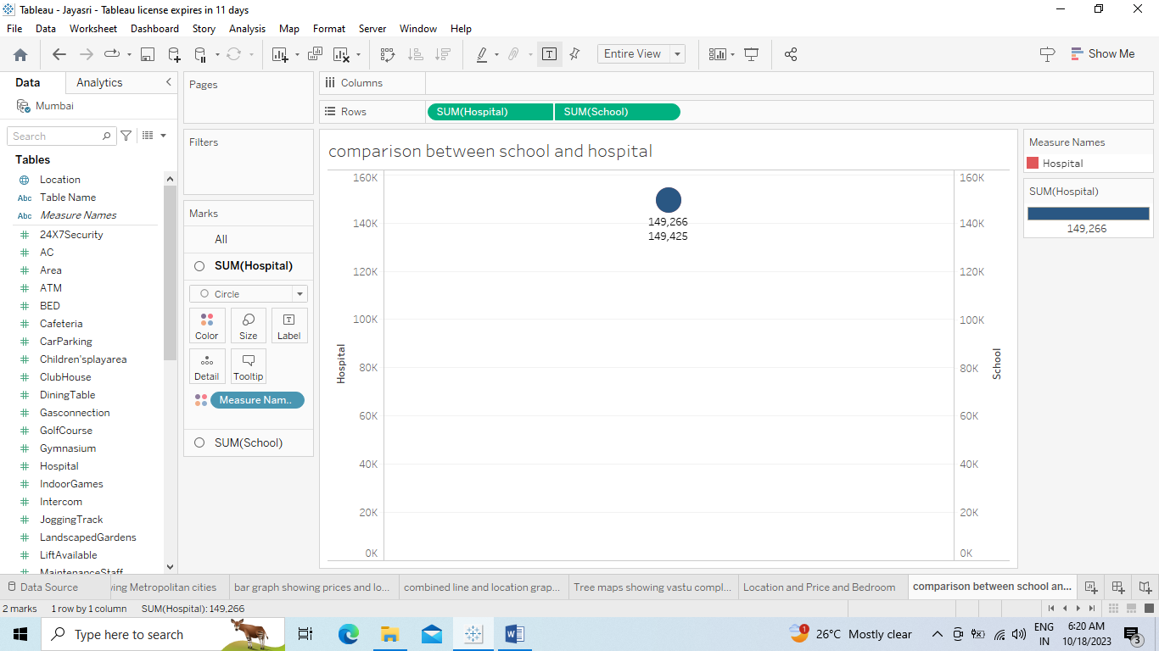

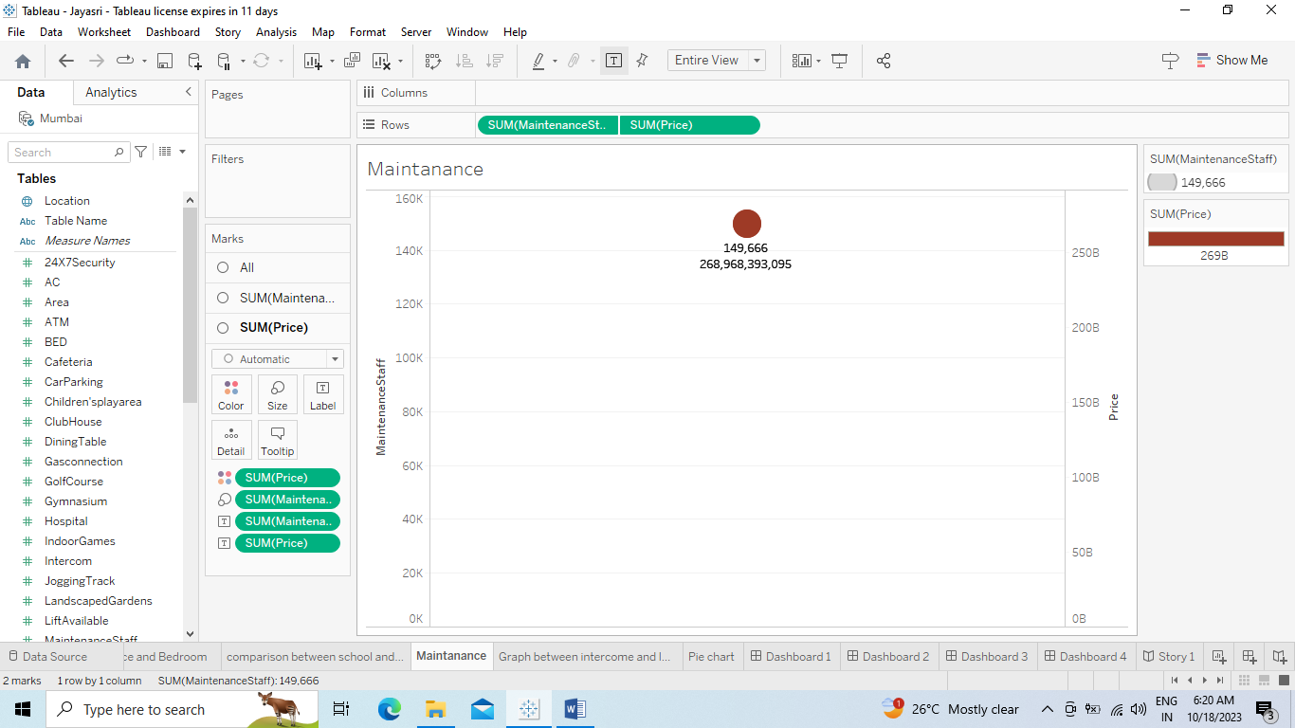

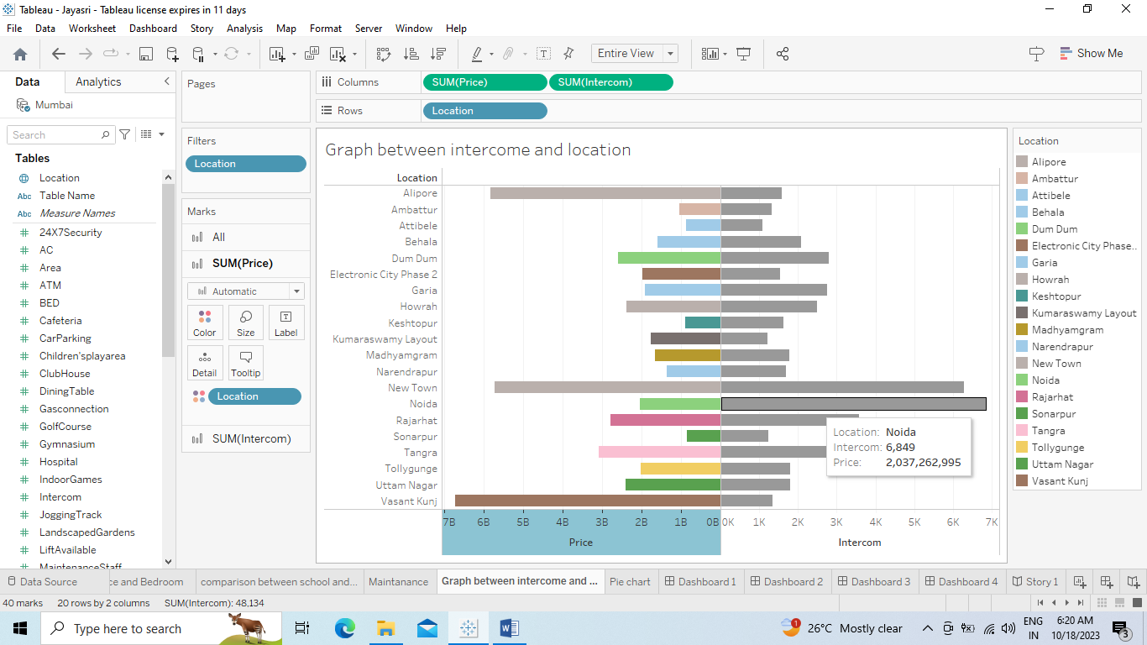

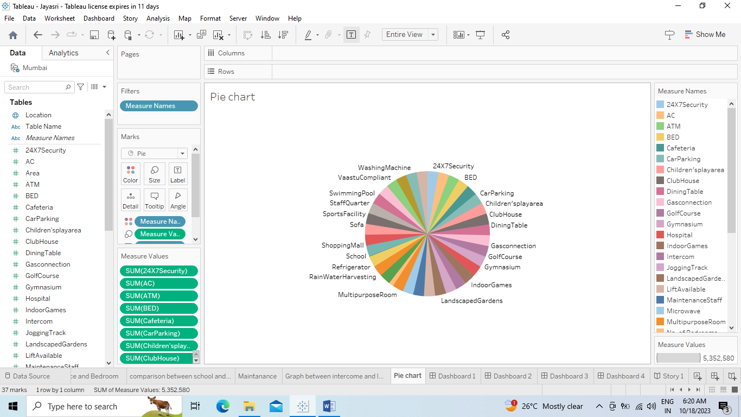

Dash boards

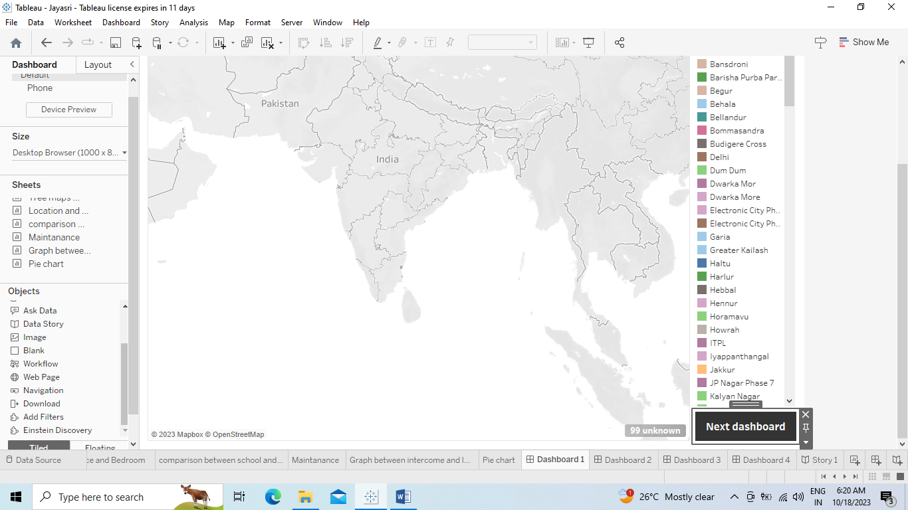

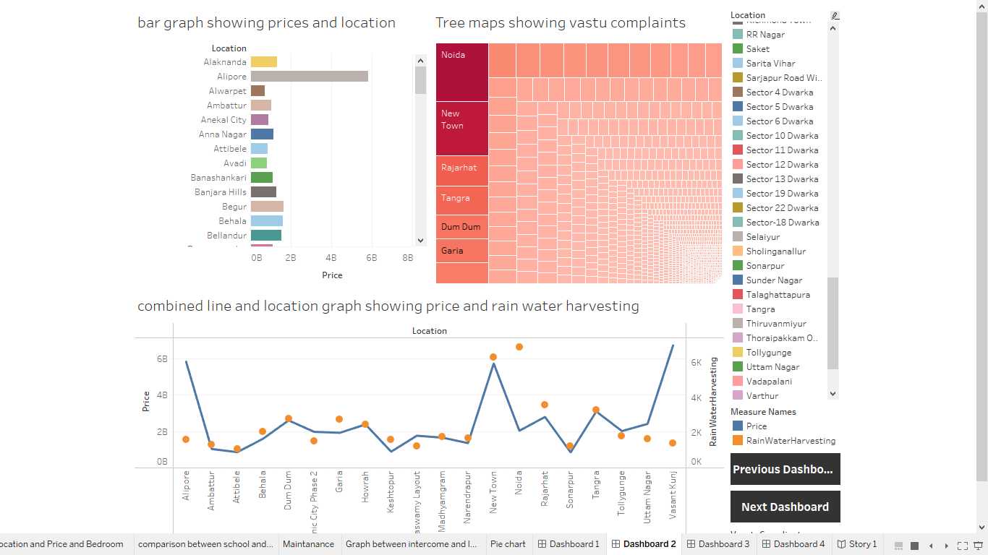

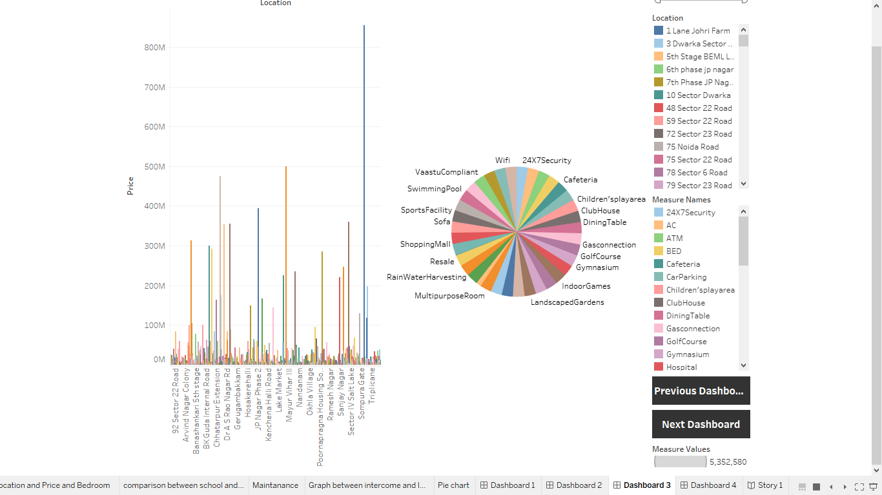

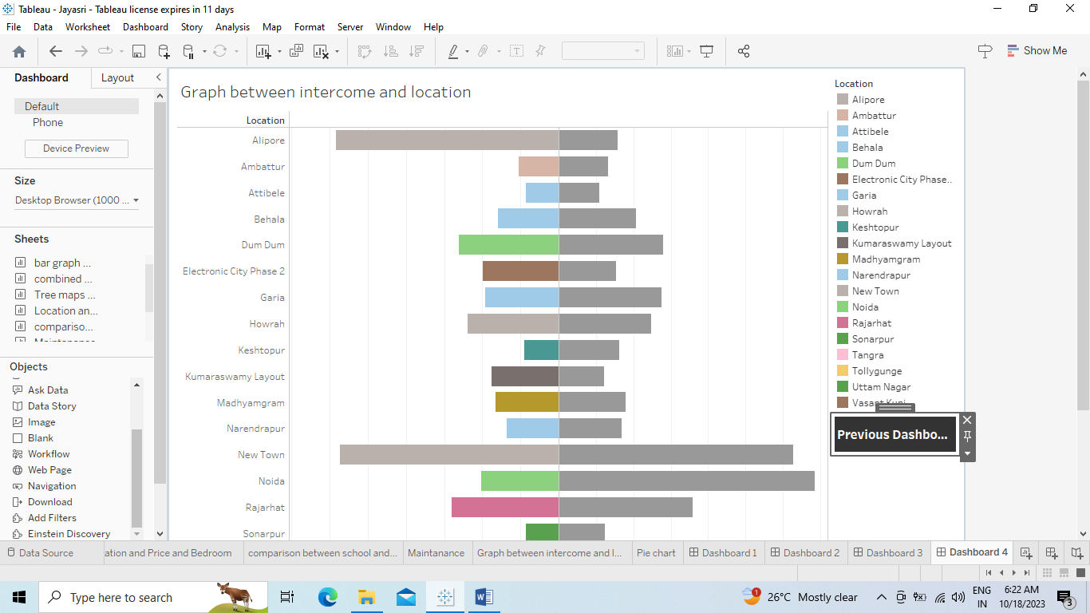

Story

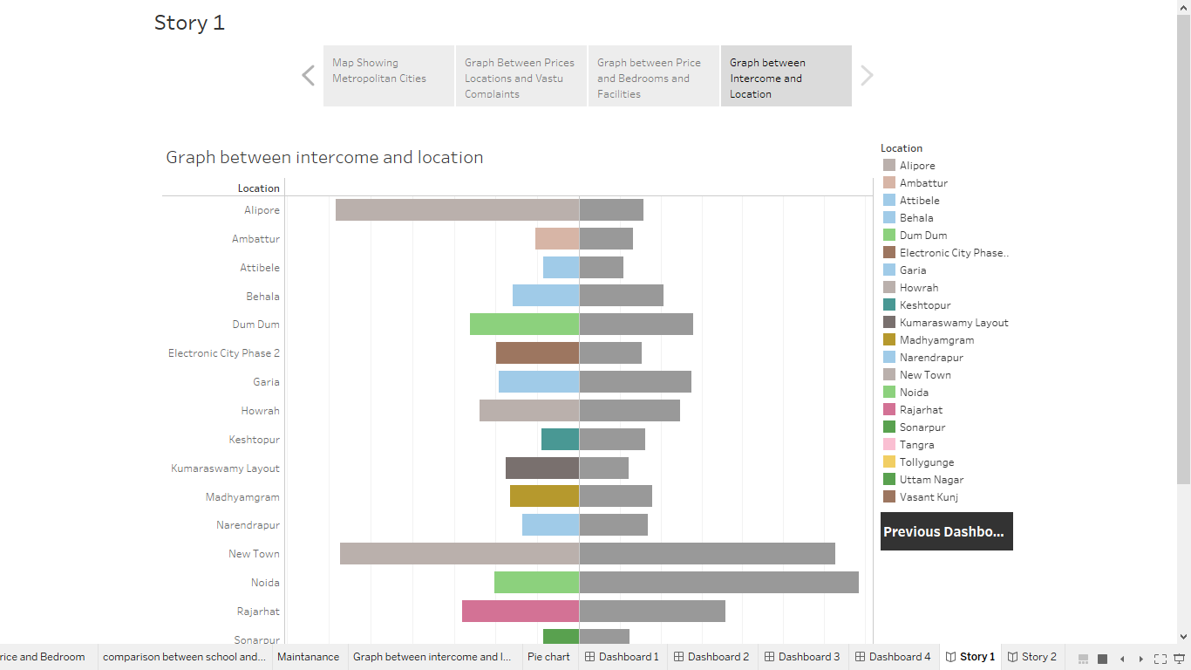

* 1. Advantages & disadvantages

Advantages:

Informed Decision Making: Analyzing housing prices helps potential buyers, sellers, and investors make informed decisions based on market trends and projections.

Policy Development: Government agencies can use this data to formulate housing policies, ensuring affordability and addressing housing shortages.

Economic Indicator: Housing prices serve as an economic indicator, reflecting the health of the real estate market and overall economy.

Investment Opportunities: Investors can identify lucrative opportunities based on areas with potential for property value appreciation.

Disadvantages:

Accuracy: Data accuracy and reliability can be a challenge, as sources may have discrepancies, leading to skewed analysis and flawed conclusions.

Speculation: Extensive analysis can lead to speculation, influencing market dynamics and causing artificial price fluctuations.

Market Volatility: Overreliance on housing price analysis can contribute to market volatility if investors react impulsively to short-term trends.

Social Displacement: Rapidly rising housing prices can lead to social displacement, pushing lower-income families out of their neighborhoods due to gentrification.

* 1. Conclusion

I don't have real-time data to provide a current analysis of housing prices in metropolitan areas of India. However, I can tell you that housing prices in metropolitan areas are influenced by various factors such as economic growth, demand and supply dynamics, infrastructure development, and government policies. To draw a conclusion about the housing market in specific metropolitan areas, you would need to analyze the latest data from reliable sources, consider these influencing factors, and consult experts in the real estate industry.

* 1. Future Scope

Analyzing housing prices in metropolitan areas of India provides valuable insights into real estate trends, investment opportunities, and economic stability. As for the future scope, continued analysis can help predict market trends, allowing investors and policymakers to make informed decisions. Factors such as urbanization, infrastructure development, and economic growth will likely influence housing prices, making ongoing analysis crucial for stakeholders in the real estate industry. Additionally, incorporating data analytics and machine learning techniques can enhance the accuracy of predictions, aiding in long-term planning and investment strategies.